As anticipated, in the second part of this course we will focus more on applications and less on theory (yay!).

To do so, in the second part of the course we will use many “packages” that do not come with the standard Python interpreter that you installed at the beginning of this course.

Installing “packages” in Python is very simple and can be done using the “pip” command, which automatically fetches packages from the Internet and installs them on your computer.

Just follow these steps:

1. Check that pip is installed correctly on your machine. To do so, you need to open the “Command prompt” in Windows (or “Terminal” if you are using Mac OS)*, type pip and press enter, the outcome should look like this:  
   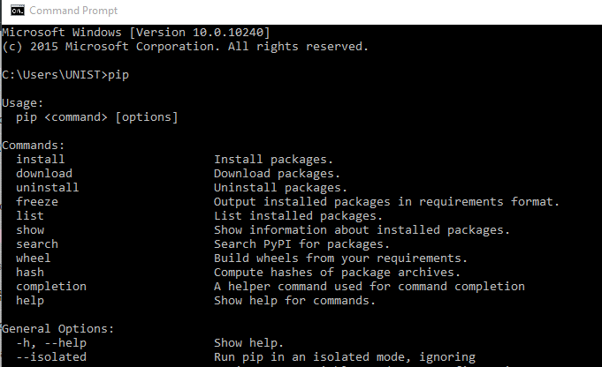  
   * in Windows 10, you can just search for “Command” in the task bar. In older versions, you can find the Command prompt under Accessories in the start menu.  
     
   If you get a message like “pip not found” or “pip is not a valid command”, then please contact me.
2. If pip installed correctly, installing packages is very simple, just make sure your computer is connected to the Internet, and then type:  
      
   pip install <package_name>  
     
   and then press enter.  
     
   Example: pip install nltk  
     
   You should install the following packages (in this order!):

|  |  |
| --- | --- |
| ***Package name*** | ***Notes*** |
| nltk | For text and natural language processing |
| bs4 | For parsing html documents into strings |
| tweepy | For accessing the Twitter API |
| python-gmaps | For accessing the Google Maps API |
| numpy | Required by package Networkx |
| matplotlib | Required by package Networkx |
| networkx | For graph definition and processing |

If you get any error or strange message, please let me know.